**ANNANDALE NORTH PUBLIC SCHOOL PARENTS AND CITIZENS ASSOCIATION**

**Minutes of Wednesday 2nd August 2016 meeting 7:30pm**

1. **Welcome:**We acknowledge the Gadigal people of the Eora Nation who are the traditional custodians of the land on which we stand. We pay our respects to elders past and present*.*
2. **Apologies:** Sarah Taylor-Holmes, Nick Holmes and Dale Wilson
3. **Attendance:** Members: Ruth Lyons, Gordon Howe, Anne Ryan, Jacqui Owen, Annette Walker, Ian Cranwell, Ali Donaldson, Andrew Pattinson, Anna Swanson, Brooke Meany, Evan Hollands, Sally Webb,Wendy Routledge, Tracey Blow, Samantha Nichols (ex officio)

Non members: Josh Collins, Melanie Oxley

1. **Confirmation of previous minutes:**

4.1 June meeting; Moved Ruth Lyons, seconded Lisbeth Kennelly. Carried unopposed.

1. **Business arising previous minutes:**
   1. P&C property inventory update: Ruth Lyons and Pen Bye have commenced an inventory of P&C items at school. Items are located either: in the cupboard underneath the stairs near the kindy block or in the disabled toilet near the SPR rooms. Ruth suggested a light be purchased for the cupboard under the stairwell which the Exec will look into. Left over mother’s day gifts have been sorted & can be used as father’s day gifts and are located in the disabled toilet. Ruth and Pen are yet to make it to Storage King but will do so in coming weeks. Thank you to both Ruth & Pen for helping.
   2. Use of P&C equipment by others: Ian Cranwell noted some P&C equipment has either been misused or broken and permission not obtained to use. Tables have been broken and a potentially dangerous gas leak and explosion with old BBQ. These items have now been fixed and signs for tables will be made and a safety checklist for BBQ use created so that those using can ensure items are safe and to whom to report damage and have permission to use from P&C executive.
   3. BBQ damage and care:

The seal between regulator hose and bottle must be checked every time. One has again been dragged on the ground, abrading the rubber seal. This is what caused the fireball on the old barbecue. Seals and functioning must be checked every time.

* 1. Parking changes and kerb extensions on Johnston St: P&C put forward suggestions for changes to parking on Johnston st and bus zones outside the school. ANPS children have liaised with St Brendan's on “clip on” signs but these would need to be sought from RMS because it manages Johnston St. The same parking issues remain outside the school with some parents not obeying the “kiss and drop off” signs which hampers traffic at peak times. The children will talk about this at the FSA on 3rd August.
  2. **Resolved:** That the P&C contributes $6,000 to the Stage 3 Mural Project that was initially discussed at the May P&C Meeting. As per the May minutes it was agreed in principle that the P&C supports the proposal. The total project cost is $6,600, and the students (with teachers' direction) would be responsible for raising $600 towards the initiative. The project is slated to take place in Week 6 of this term. Moved Sarah Taylor-Holmes, seconded Ali Donaldson, carried unopposed.

**6**. **Reports:**

6.1 President - no report this month

6.2 Treasurer - see attached

6.3 Principal - see attached

7. **Committee updates:**

7.1 **Fundraising:**

* Wine tasting: Thank you to Sally Webb for arranging the night and to Sarah O’Brien for the beautiful table styling. The event raised over $2,200 and wine can still be purchased through the website. Increased advertising reminding parents of the fundraising initiative to come. Sally is happy for wine night profit to go towards the Mural.
* Election fete: The event raised over $6,000 with big thanks to Ben Southwell from Cobden Hayson and the many parent helpers on the day.
* Thanks to all volunteers involved with recent events
* Fundraising committee members, still required and needed to plan big event in 2017. See Lisbeth if you are interested.
* FSA Kindy cupcakes Thursday 4th August.
* Father’s day stall coming up (2nd September) allocated to Yr 1 to coordinate.
* It was suggested the date of the October meeting be changed to allow new parents at the Kindy information night to attend part of the meeting in a more social environment. Sally may assist with drinks on the night. Tentative for the 19th Oct with no November meeting as a result.

7.2 **Band and Strings:** no report this month

7.3 **Facilities:** no report

7.4 **Grants:** Evan and Ainslie are applying for a variety of Grants which may help to purchase playground equipment or contribute to the school mural. Application made for Community Building Partnerships grant for playground equipment and the Inner West Grant may help with the mural. Evan suggested the school provide a wish list to the P&C which will help identify which Grants should be targeted. A variety of different industries have grants such as Ikea for furniture which previously may not have been known. Evan is also looking into google apps to assist the Exec with communication and a “salesforce customer relations app” which can track the history of local businesses who participate in events at the school. A calendar of when grants open and close is also being explored.

7.5 **Supporting Quality Learning:** no report this month

8. **New business:**

8.1 Executive positions for 2017.

Only two more P&C meetings until AGM. Current president not at school, Secretary ineligible under current rules, having served three terms. New people required for 2017.

8.2 Urban Growth presentation to ANPS class: held over to next meeting

9. **Correspondence:**

* Fundraisingbrochures

**Meeting closed 8:30pm**

Treasurers Report

(ANPS P&C Meeting, 3rd August 2016)

* Profit and Loss for the main P&C accounts for the month of June/July 16 as below:

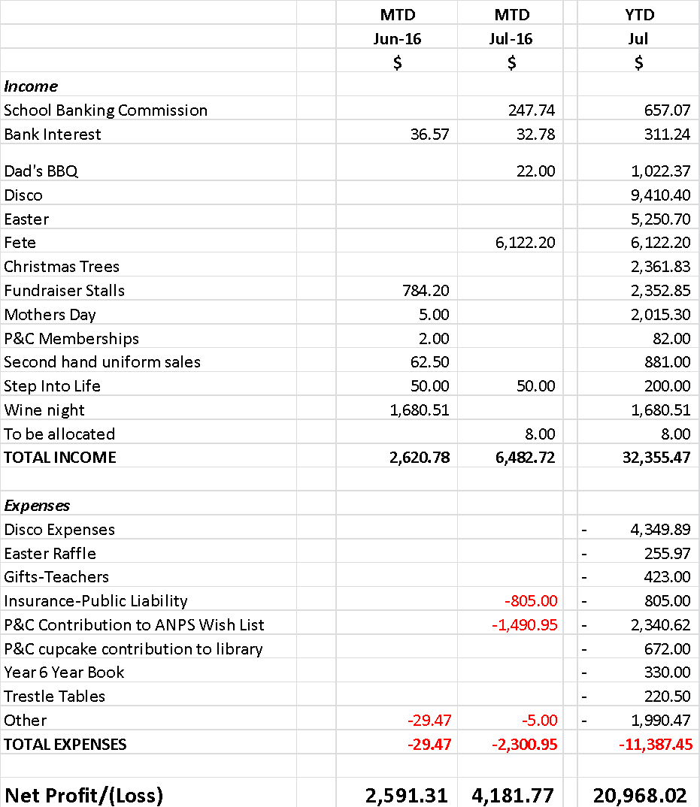

**Principal’s Report 3 August 2016**

A little about my background - I have been a passionate classroom teacher for over 25 years.. Thank you for the warm welcome to the school. I am enjoying working with the staff and students immensely. I wanted to thank Josh and the executive team Melanie Oxley, Jane Fox and Jo Kearney for managing the school prior to my appointment. I have arrived in very well organised school.

A little about my background - I have been a passionate classroom teacher for over 25 years. I spent 11 years in London where I was involved with implementing the then new National Curriculum. I worked on many projects, but had a major focus on science education, reading difficulties and computer literacy. Returning to Sydney, I worked in the independent sector for several years before securing a job at Beecroft Public School. At Beecroft I worked to develop the MyScience project, a program that matches scientists with groups of students to mentor them through their own investigations. I was also tasked with implementing the Gifted and Talented policy. Having and OC class for 6 years gave me a valuable understanding of the challenges around gifted education. I moved to Woollahra PS as an Assistant Principal and later became the Deputy Principal and Relieving Principal. Over my time there I oversaw the implementation of the new curriculums, as well as reviewing the school welfare and discipline policy, developing mentoring programs in writing, initiating mathematics extension courses for the school and overseeing the Learning and Support team. Woollahra is a busy school with a myriad of extra curricular activities both before and after school which I co-ordinated.

I have always enjoyed a positive partnership with the parent community and I look forward to connecting with the Annandale North families over the coming time. I live locally in Glebe and will be walking to work – a fortunate situation to be in, and one I tend to enjoy for many, many years.

Working towards the new Local Management and Business Reform project (LMBR) is the primary focus for the school over the coming term. This involves learning the new systems in the office for purchasing and tracking of finances. There will be changes that need to be made, the first of which was noted in the letter sent home with term accounts last week. Parents will also no longer be able to pay for things by credit card at the office. Online payments (POP) and cash will be the primary methods of payment. As the office staff and school staff learn these new systems, there may be some delay in processing payments and we ask that parents are aware of the challenges we are facing at the moment. I will keep you posted about any further updates in the newsletter.